Dynamic Graph Optimization and Automated Feature Extraction for Efficient Intrusion Detection in Network Systems

Under the Supervision of

SURESH A
Associate Professor Grade 1
School of Computer Science and Engineering (SCOPE)

B.Tech.
in
Computer Science and Engineering

School of Computer Science and Engineering



October 2025
ABSTRACT
Modern Network Intrusion Detection Systems (NIDS) increasingly utilise machine learning models to enhance threat detection by effectively analysing complex data patterns in network traffic. Graph-based techniques have been especially effective, utilising deep network relationships and detecting subtle irregularities that traditional signature-based methods often miss. These sophisticated models integrate both structural and temporal information, capturing network topology and entity relationships while enabling comprehensive analysis of attack progression patterns, allowing for early detection of sophisticated and evolving multi-stage intrusion campaigns.
Despite their significant analytical strengths, existing graph-based systems frequently require extensive manual configuration by domain experts and impose high computational costs, restricting their scalability and real-time usability in diverse operational contexts. These limitations particularly affect deployment in resource-constrained environments where computational efficiency is paramount for practical implementation.
This research addresses these fundamental constraints by implementing an innovative dynamic graph-pruning technique that uses attention scores to eliminate less important nodes and edges dynamically during inference, utilising the PyTorch Geometric framework for efficient graph operations. The attention-based mechanism continuously evaluates component relevance, automatically removing low-importance elements while preserving critical pathways that significantly contribute to threat detection decisions. Additionally, an automated feature extraction process is employed, using tools such as Scikit-learn to automatically derive meaningful correlations, temporal patterns, and behavioural anomalies from raw network data without manual intervention.
Extensive evaluations performed on widely recognised benchmark datasets, including CIC-IDS2018 and NF-UNSW-NB15-v2, validate the efficiency of these enhancements by demonstrating reduced memory consumption, lower processing latency, and improved detection accuracy across various attack categories. These optimisations collectively advance the adaptability and overall effectiveness of NIDS solutions, making them substantially more suitable for deployment in resource-constrained network environments.

TABLE OF CONTENTS
Sl. No | Contents | Page No.
 | Abstract | 2
1. | INTRODUCTION | 4
 | 1.1 Background | 4
 | 1.2 Motivations | 4
 | 1.3 Scope of the Project | 5
2. | PROJECT DESCRIPTION AND GOALS | 6
 | 2.1 Literature Review | 6
 | 2.2 Gaps Identified | 12
 | 2.3 Objectives | 13
 | 2.4 Problem Statement | 13
 | 2.5 Project Plan | 14
3. | REQUIREMENT ANALYSIS | 16
 | 3.1 System Requirements | 16
 | 3.2 Functional Requirements | 18
 | 3.3 Non-Functional Requirements | 21
 | 3.4 Data Requirements | 21
4. | IMPLEMENTATION | 23
 | 4.1 System Architecture | 23
 | 4.2 Workflow Model | 24
 | 4.3 Module Design and Implementation | 25
5. | RESULTS | 31
6. | CONCLUSION | 33
7. | REFERENCES | 33

1. INTRODUCTION
1.1 BACKGROUND
Network Intrusion Detection Systems (NIDS) have evolved from traditional signature-based approaches to sophisticated machine learning solutions capable of identifying complex attack patterns. The integration of Graph Neural Networks has marked a significant advancement, with recent research demonstrating the effectiveness of Heterogeneous Temporal Graphs (HTGraphs) in network flow analysis. These approaches represent network flows as HTGraphs with nodes corresponding to dynamically updated features and three types of edges: homogeneous (same feature type), heterogeneous (cross-feature correlations), and temporal (time-based dependencies).
Recent innovations have introduced Heterogeneous Temporal Graph Neural Networks with separate GATv2 layers for different edge types, and Adjustable Early Detection Decoders enabling flexible observation windows. Despite achieving superior performance, current graph-based NIDS face critical limitations: computational complexity that scales quadratically with graph size, extensive memory requirements that challenge deployment in resource-constrained environments, and manual feature engineering requirements that limit adaptability across diverse network environments.
The dynamic nature of modern cyber threats demands NIDS solutions that can adapt quickly to new attack patterns while operating efficiently within computational constraints. Traditional approaches often struggle with the heterogeneous nature of network features and the temporal dependencies inherent in network traffic, leading to suboptimal performance in real-world deployment scenarios.

1.2 MOTIVATIONS
Modern network environments, particularly IoT ecosystems and edge computing infrastructures, operate under significant resource constraints where traditional graph-based NIDS become impractical due to their computational overhead. The need for real-time intrusion detection with millisecond response times further exacerbates these challenges, as current approaches struggle to meet stringent latency requirements during graph construction and neural network inference phases.
The dynamic nature of network environments reveals another critical limitation: static graph structures fail to adapt to varying traffic patterns and computational availability. Current systems require extensive domain expertise for configuration, creating a significant bottleneck for widespread adoption. Network administrators often lack the specialized knowledge required to properly configure complex graph-based systems, limiting their practical deployment.
Scalability challenges become particularly acute as network infrastructures continue expanding, demanding NIDS solutions that demonstrate linear rather than quadratic complexity growth. Organizations require solutions that can scale with their growing network traffic without proportionally increasing computational costs or degrading performance.
Automated feature engineering represents a crucial gap in existing solutions. Current graph-based NIDS rely heavily on manual relationship definition, requiring significant expertise and limiting generalizability across different network environments. The absence of intelligent feature extraction and relationship discovery mechanisms prevents these systems from adapting to new attack patterns without extensive reconfiguration, creating maintenance overhead and reducing system effectiveness.

1.3 SCOPE OF THE PROJECT
This project addresses the computational and scalability limitations of existing graph-based NIDS through two primary innovations: Dynamic Graph Pruning and Automated Feature Extraction. These enhancements enable practical deployment in resource-constrained environments while maintaining sophisticated detection capabilities.
Dynamic Graph Pruning implements attention-based algorithms to identify and eliminate redundant nodes and edges during inference, reducing computational overhead while maintaining detection accuracy. This approach enables adaptive resource management, allowing systems to scale complexity based on available computational resources and performance requirements. The pruning mechanism operates intelligently, preserving critical relationships while eliminating redundant connections.
Automated Feature Extraction eliminates manual engineering requirements through intelligent algorithms that discover feature correlations, categorize features into appropriate types (time, packets, binary, bulk, window), and establish graph relationships automatically. This capability significantly enhances system adaptability and reduces deployment complexity across diverse network environments, enabling rapid deployment without requiring specialized expertise.
Evaluation and validation utilize benchmark datasets including CIC-IDS2018 and NF-UNSW-NB15-v2 to assess detection accuracy, memory consumption, inference latency, and scalability characteristics. The expected impact includes enabling deployment in IoT networks, edge computing infrastructures, and enterprise environments where computational resources are limited, while providing automated adaptation capabilities that reduce configuration complexity and enable rapid deployment across diverse network environments.

2. PROJECT DESCRIPTION AND GOALS
2.1 LITERATURE REVIEW
Wang et al. (2024) introduced K-GetNID, a novel early-and-transferable NIDS framework that represents each network flow as a Heterogeneous Temporal Graph (HTGraph). In this scheme, flow features of different types (e.g., time-series, packet-level, bulk, windowed) become distinct node types, with edges encoding both intra-type similarity and inter-feature correlations. The authors then designed a corresponding HTGNN (heterogeneous temporal GNN) that applies type-specific GATv2 attention layers for message passing. Crucially, K-GetNID incorporates an Adjustable Early Detection Decoder that yields predictions at multiple packet-count horizons, allowing the system to trade off accuracy for detection latency. Evaluated on CIC-IDS-2017 and UNSW-NB15, K-GetNID matched state-of-the-art deep models when full flows are available and outperformed baselines for partial flows, demonstrating significantly higher precision/recall under limited observation. The authors attributed this to their knowledge-guided graph design, which embeds domain structure (feature types and correlations) into the model. They also showed that this leads to better cross-domain transferability, since the graph construction reduces overfitting to any one dataset. The primary contribution was formalizing flow features as graph nodes guided by domain knowledge, rather than using host-topology graphs. However, Wang et al. did not address model efficiency at inference: their HTGraphs are static and relatively dense, and the decoder design does not consider resource constraints. They also did not explore how to prune or compress these graphs dynamically. For our project, K-GetNID’s HTGraph and multi-window decoder establish the baseline representation and early-detection mechanism. Its focus on inter-feature relations validates learning on structured graphs. The open challenge is extending this design to adaptive pruning: specifically, to maintain the decoder’s multi-horizon performance while sparsifying the HTGraph at runtime. Thus, K-GetNID motivates our work in that we will use its graph construction as a template and then investigate how to remove redundant nodes/edges without sacrificing early-detection accuracy (Wang et al., 2024).
Xiaoyan Hu et al. (2023) tackled the early intrusion-detection problem by embedding partial flow graphs. They modeled each bidirectional network flow as a compact graph of packets and applied a graph embedding pipeline (e.g. Graph2vec) to map this graph into a fixed-length vector. A lightweight classifier (such as a random forest or shallow MLP) then labels the flow. The key insight was that graph embeddings can capture packet-order and relational motifs that flat feature vectors miss. In experiments on CIC-IDS datasets, Hu et al. showed that even with only the first few packets of each flow, their graph-based method preserved discriminative structure: it achieved materially higher early-detection precision and recall and lower time-to-detection than tabular-feature baselines. This demonstrated that compact graph encodings recover relational cues lost by conventional feature extraction. The paper’s main contribution was confirming that transitioning from feature sequences to graph representations yields stronger signals for early detection, obviating the need for extensive manual feature engineering. However, the approach had limitations: it always built the full flow graph (or full partial-flow graph) and did not consider runtime graph optimization or pruning. The embeddings were computed in batch, without adaptation for resource constraints, and the method did not exploit attention or GNN layers for selective focus. For our project, Hu et al.’s findings directly support the use of HTGraphs: they validate that graph-based embeddings hold crucial timing and relational information. Their results motivate pruning strategies that preserve only the most informative substructures of these graphs, since those are the ones driving classification performance when flows are short. In particular, we will draw on their premise that graph form retains early-warning signals, and we will design methods to sparsify graphs (e.g. by removing edges or nodes) while keeping these motifs intact (Hu et al., 2023).

Duan et al. (2022) proposed a Dynamic Line-Graph Neural Network (DLGNN) to detect intrusions in streaming environments. They transformed the sequence of packets or communications into a line graph where each original edge (e.g. a packet transfer) becomes a node in the line graph. The DLGNN then operates on the evolving line graph, using temporal snapshots and aggregation to capture how interactions change over time. Importantly, Duan et al. integrated semi-supervised learning: they used label propagation and consistency regularization so that sparse attack instances (rare “edges”) are emphasized even without full supervision. On public NIDS benchmarks, this approach boosted recall on low-support attack classes compared to standard sequence models, at the cost of fewer parameters: by collapsing redundant temporal links into line-graph nodes, the representation compressed the data. The novelty of the work was twofold: first, representing flows via a line-graph elevates edge sequences to first-class status, which better encodes transition semantics; and second, updating the graph dynamically enabled online inference and continual training. For our objectives, DLGNN’s insights are highly relevant. It suggests that choosing an alternative graph transformation changes the information bottleneck in useful ways. In particular, it motivates designing edge-aware pruning heuristics for our HTGraphs: we may treat edges (or nodes corresponding to packet transitions) as units to either preserve or drop. Duan et al.’s use of semi-supervised signals also implies we should be careful not to prune away rare-attack cues. Thus, we plan to incorporate similar regularization ideas so that our pruning decisions favor keeping elements with high anomaly potential (Duan et al., 2023). Note that DLGNN focused on streaming detection rather than flexible early-detection horizons; bridging this to our adjustable decoder is an open area.

Pei et al. (2024) presented NIGNN, a graph neural network for NIDS that explicitly incorporates privacy-preserving mechanisms into its architecture. The core idea was to design the GNN message-passing so that node attributes are not directly exposed. They introduced a privacy-enhanced aggregation: each node adds noise proportional to its degree when contributing to neighbors, and the attention mechanism is masked or gated to restrict the context seen by any node. The result is a model with formal differential privacy guarantees: sensitive flow attributes (e.g. raw packet statistics) remain obfuscated even as information is shared across the graph. On standard flow datasets, NIGNN maintained accuracy close to non-private GNNs while significantly reducing information leakage. The primary contribution is showing that one can preserve structural learning capability in a GNN for NIDS without violating privacy constraints from legal policies. This is relevant to our project because it suggests that sparsification can aid privacy as well as efficiency. For instance, pruning low-attention neighbors (which NIGNN already biases) would further remove contexts where noise is added. The design choices in NIGNN - degree-sensitive masking and gated attention - are compatible with our goal: we can interpret pruning as a form of attention gating. A remaining challenge is to ensure that adaptive graph sparsification does not break these privacy guarantees or degrade detection of rare attacks. We will examine how pruning low-impact nodes intersects with differential privacy: ideally, pruning should reinforce privacy (by cutting potential leakage channels) while retaining the critical edges NIGNN would consider, per its privacy-accuracy trade-off (Pei et al., 2024).

Mao et al. (2025) introduced FeCoGraph, a framework that fuses federated learning and graph contrastive learning for few-shot intrusion detection. Each client converts its flows into line graphs and trains a local GNN with a label-aware contrastive objective: samples from the same class are pulled together in embedding space, while different-class embeddings are pushed apart. This improves class discriminability even with few labeled samples. Clients periodically share model updates (not raw data) with a central server, which aggregates them in a federated manner. FeCoGraph also uses a contrastive loss that explicitly leverages the sparse labels available. Experiments on cross-domain few-shot tasks showed that FeCoGraph outperformed both centralized and naive federated baselines by a significant margin: in one case it improved accuracy by ~8% over an e-graphSAGE baseline. The main contribution is demonstrating that combining label-guided graph contrastive pretraining with federated aggregation produces transferable, compact embeddings for few-shot NIDS. For our purposes, FeCoGraph’s success indicates that our automated feature extraction should target representations amenable to contrastive and federated learning. In other words, after pruning we should still be able to form embeddings that maintain inter-class margins. This suggests pruning must preserve the “positive pair” substructures that contrastive learning exploits. We will therefore test whether pruned HTGraph outputs remain well-separated in embedding space, following FeCoGraph’s paradigm (Mao et al., 2025). The use of line graphs in FeCoGraph also underscores that the specific graph form (flow vs. feature graph) can vary with similar principles.

Verkerken et al. (2023) proposed a pragmatic multi-stage hierarchical IDS to improve scalability and zero-day detection. Their system has a lightweight first stage that applies statistical tests, sketches, or simple binary classifiers to quickly filter out most benign flows. Flows deemed suspicious are escalated to one or more heavier stages with richer features and machine learning models. Crucially, they also included unsupervised novelty detectors at the front to catch unusual patterns that merit escalation. This tiered approach was validated on CIC-IDS datasets: it achieved high balanced accuracy (~96%) and correctly flagged most previously unseen attacks while cutting the amount of data processed by deep models by roughly 60–70%. The novelty of the work is its integrated escalation logic, which uses confidence thresholds to decide when to pass flows to deeper analysis. For our design, Verkerken et al.’s multi-stage blueprint is instructive: our dynamically pruned HTGNN would naturally fit as a mid-to-late stage, operating on flows already flagged as suspicious. In that role, we can prune aggressively to reduce the graph size (since we expect few flows to reach us), relying on the assumption that trivial cases have been filtered out. Verkerken et al. also suggest using strict handoff criteria; analogously, we will tie our pruning aggressiveness to upstream confidence scores. In summary, the multi-stage insight confirms that we need not apply the pruned GNN to all traffic, and guides how to coordinate our pruning with earlier screening (Verkerken et al., 2023).

Radoglou-Grammatikis et al. (2025) introduced AI4FIDS, a federated, multimodal IDS tailored to critical infrastructure. It jointly processes flows, host logs, and application-level telemetry while preserving data privacy via local model updates. The authors compared various federated aggregation strategies (FedAvg, robust aggregation, attention-based) under both non-IID distributions and adversarial label poisoning. They found that fusing multiple data modalities significantly outperformed single-modality models, and that robust aggregation schemes could mitigate some poisoned updates. The main contribution is evidence that cooperative federated learning with heterogeneous inputs dramatically improves detection of complex, multi-stage intrusions common in industrial settings, without centralizing raw data. This work is relevant for us because it highlights requirements for pruned graph representations in a federated pipeline: our HTGraph outputs should be compact, semantically consistent, and low-bandwidth so they can be aggregated across clients. It also underscores the importance of consistent normalization and modular feature design. For example, the need for robust aggregation suggests we should ensure our pruning does not introduce instabilities or amplify client bias. In practice, we will evaluate whether compact HTGraph features integrate smoothly with federated protocols (Radoglou-Grammatikis et al., 2025).

Yilun Hu et al. (2023) proposed PFTD, a privacy-preserving few-shot framework for APT detection via federated meta learning. In PFTD, each client collects a small support set of known attack flows and a query set of unlabeled flows. Each client fine-tunes a local model on its support set and evaluates on its query set, then sends gradients (not raw data) to a server. The server aggregates these meta-gradients to update a global model initialization. This meta-learning loop enables the model to quickly adapt to new attack variants with only a few examples, while never transmitting sensitive flows. PFTD also integrates lightweight differential privacy and client-specific personalization to prevent catastrophic forgetting of local patterns. Empirical results showed that with only a handful of labeled flows per attack, PFTD achieved high detection accuracy and adapted rapidly to held-out domains. The contribution is demonstrating that federated meta-learning can effectively detect rare, stealthy attacks (APTs) under privacy constraints. For our objectives, PFTD highlights that graph-based features should remain amenable to meta-learning: the pruned HTGraph embeddings we produce must still support fast adaptation and federated aggregation. We will test whether pruning degrades this few-shot adaptability. In particular, we may incorporate meta-learning in our pipeline so that pruned graphs can still be fine-tuned with minimal data, as suggested by PFTD’s design (Hu et al., 2023).

Bouzinis et al. (2025) introduced StatAvg, a lightweight preprocessing technique to reduce non-IID feature mismatch in federated NIDS. In StatAvg, each client computes local statistics (means, variances) of its training features and sends them to the server. The server aggregates these into global statistics, which it shares back with clients. Each client then normalizes its data using the global mean/variance before federated training. This simple extra step dramatically aligned feature distributions across clients. On heterogeneous IoT and enterprise intrusion datasets, StatAvg accelerated federated convergence and improved detection accuracy (notably reducing false positives) without extra raw-data sharing. The key insight is that sharing just statistical summaries eliminates much distribution drift. For our work, StatAvg underscores the importance of consistent input scaling in federated settings. We will adapt this idea by computing statistics on HTGraph node types (time series features, packet features, etc.) so that different sites normalize similarly even after pruning. One question is whether removing nodes/edges will disrupt these global stats; we will investigate if pruning can occur after StatAvg normalization or if the global stats need recalculation. In summary, StatAvg shows that harmonized inputs boost federated learning; we will incorporate a similar normalization step into our pruned-graph pipeline (Bouzinis et al., 2025).

Wu et al. (2025) proposed an anchor-graph clustering approach for IoT intrusion detection. They clustered similar flow and host behaviors into a set of anchor nodes, and then built sparse inter-anchor edges based on cluster proximity. This dramatically reduced graph density and memory requirements while retaining the structural patterns useful for classification. In experiments on IoT traffic, their anchor-based graphs were far more compact than explicit host-flow graphs, yet still enabled accurate intrusion detection. The main contribution was automating graph construction: instead of hand-crafted edge heuristics, clustering generated succinct graph motifs that preserved class-discriminative signals. This approach is well-suited to resource-constrained IoT/edge settings because of its low computational cost. However, Wu et al. sacrificed some temporal granularity in favor of spatial compactness and did not test early-detection with partial flows. They also did not examine how anchor summaries would interact with GNN attention mechanisms or federated learning: for example, the stability of anchors under non-IID client data was untested. For our work, the anchor-graph concept directly informs automated feature extraction and initial sparsification. Anchors could serve as supernodes or priors for pruning: we can start with anchor summaries and then use attention-driven pruning to refine which detailed nodes are needed. Our experiments will validate whether anchor compression preserves rare-attack cues under aggressive pruning, and whether anchor-based graphs remain effective when embeddings are synchronized across clients. These extensions will push anchor-graph ideas toward deployable, pruning-aware HTGraph pipelines (Wu et al., 2025).

Mohammadian et al. (2024) [13] proposed a pragmatic topology-driven leaf-prune reduction that removes peripheral nodes from static program and call graphs; they reported substantial runtime and memory benefits with only modest loss of central structural information, showing that very cheap topology-based heuristics can eliminate obvious redundancy before any learning step. Rabooki et al. (2025) [14] formalized graph distillation for provenance/APT graphs in GraphDART, applying condensation and core-set selection methods (random, herding, k-center) to extract compact representative subgraphs that preserve discriminative motifs; training on these distilled subgraphs produced sizable reductions in training cost while maintaining classification performance, demonstrating an optimization-driven second-stage compression complementary to simple heuristics. Wang et al. (2025) [25] contribute a different but complementary angle: they introduce a dual-channel high-order GNN (DHGNN) that separately encodes node attributes and high-order neighborhood structure, fusing the streams with channel attention to improve semi-supervised detection — a design that suggests attention and high-order aggregation can be used to prioritize informative substructures even when graphs are compressed. Taken together, these works point to two practical operating principles for pruning-aware HTGraph design: (1) inexpensive topology- and type-based coarsening (leaf/prune, component trimming) rapidly reduces graph density, and (2) learned or optimization-based condensation (distillation, core-set selection) produces compact, representative subgraphs for downstream learning. They also expose important gaps: few studies systematically evaluate early-detection latency, rare-class recall under aggressive pruning, or interactions with multi-horizon decoders. For our pruning-aware HTGraph + HTGNN pipeline these findings motivate a hybrid approach — fast structural coarsening followed by learned distillation or attention-guided refinement — paired with a strict evaluation regime that measures time-to-detection, per-class recall, and memory/latency tradeoffs, and includes anomaly-preserving regularizers so low-support attack cues are not inadvertently discarded.

Basak et al. (2025) [11] (X-GANet) combined GNN encoders with transformer-style embeddings, multi-scale anomaly scoring, cross-diffused attention, and adaptive masking to prioritize informative substructures; they showed that a coarse-to-fine attention cascade produces rapid, explainable anomaly scores and can selectively invoke heavier computation under tight latency constraints. Liu & Guo (2025) (DIGNN-A) [20] construct time-varying graphs and apply multi-head temporal attention to capture topology evolution in streaming traffic, demonstrating that temporal attention weights reliably track emergent anomalies and can serve as an online importance signal for retaining or evicting nodes and edges during inference. Li et al. (2023) [21] (EDGMAT) propose an edge-directed multi-head attention network that explicitly incorporates edge features and directionality into the attention computation; by jointly weighting node and edge attributes EDGMAT reduces manual feature engineering and identifies edges that are especially informative for classification, offering a concrete mechanism to use attention as an interpretable edge-importance signal in NIDS. Zhang et al. (2025) [23] (ResACAG) augment these ideas by adding residual connections and a global-broadcast mechanism alongside local attention to fuse long-range context and stabilize learning on larger graphs. Collectively, these works establish attention both as an interpretable importance indicator and as a natural pruning signal — attention scores can drive node/edge ranking, gate message passing, or trigger conditional activation of fine encoders in an anytime pipeline — while also warning of practical pitfalls (attention collapse on rare signals and sensitivity to non-stationarity). Robust designs should therefore include attention regularization (e.g., entropy or contrastive losses), temporal robustness measures, and evaluation under partial-flow observation windows to ensure attention-driven pruning preserves multi-horizon early-detection performance.

Bilot et al. (2025) (FEAE) framed malicious edges as few-shot categories and used self-supervised contrastive training to produce edge-centric embeddings that remained discriminative with minimal labeled examples, indicating that contrastive pretraining could make representations robust to subsequent node/edge removal [28]. Jianping Wu et al. (2024) developed a federated, attention-enabled GNN framework for network-attack detection and showed that locally computed attention-weighted summaries (fingerprint-weighted Jaccard or analogous measures) could be aggregated without sharing raw flows; their results implied that attention scores could double as compression criteria for transmitted summaries, thereby preserving privacy while reducing communication overhead [19]. Ngo et al. (2025) proposed a Top-K similarity graph construction and sampling-based GraphSAGE pipeline for IoT, linking nodes to their K most similar peers to produce sparse but informative graphs that reduced density while maintaining neighborhood signal and cross-domain transferability [18]. Together, these works suggested a practical federated pipeline for pruning-aware HTGraphs: construct compact local graphs (Top-K or anchor summaries), pretrain encoders with contrastive/few-shot objectives so embeddings tolerate pruning, and exchange only distilled summaries or attention-ranked updates to limit bandwidth. The cluster also raised empirical questions we must answer, how local pruning affects federated aggregation and personalization, whether contrastive pretraining preserves rare-attack separability on pruned subgraphs, and the precise communication-versus-accuracy trade-offs when only attention-ranked features are shared, experiments that are essential before deploying pruning strategies in distributed, heterogeneous environments.

2.2 GAPS IDENTIFIED
A major limitation of current graph-based Network Intrusion Detection Systems lies in computational scalability. The construction of heterogeneous temporal graphs requires substantial memory and processing resources, which grow quadratically with the number of nodes and the temporal depth of observation. This scalability bottleneck becomes particularly severe in real-time environments, where the system must process massive amounts of traffic continuously, making existing approaches impractical for deployment in large-scale or resource-constrained networks.
Another critical gap is the heavy dependence on manual feature engineering and domain expertise. Most existing implementations require experts in both cybersecurity and graph theory to carefully design features and graph structures. This reliance on handcrafted features introduces significant delays in system deployment and limits adaptability across different organizational contexts. Without automated mechanisms for feature discovery and relationship identification, current systems struggle to generalize effectively across diverse network infrastructures and attack landscapes.
The static nature of graph architectures used in existing models further limits their effectiveness. Current systems typically employ fixed graph topologies determined during preprocessing, which do not adapt to changes in computational resources or varying network traffic conditions during real-world operation. This rigidity leads to inefficient resource utilization, as redundant or minimally informative graph components are still processed, contributing to unnecessary computational overhead. Such static approaches fail to balance accuracy with efficiency in dynamic deployment scenarios.
Finally, graph-based NIDS models often demonstrate weak adaptation to evolving traffic patterns and novel attack vectors. While they may perform adequately on known datasets, their generalization capability deteriorates significantly when exposed to unseen attack types or zero-day exploits. This limitation arises from overfitting to static training distributions and insufficient mechanisms for handling distribution shifts in real-time traffic. As a result, these models exhibit reduced robustness in dynamic environments where new threats emerge continuously.

2.3 OBJECTIVES
The primary objective of this research is to design and implement intelligent graph optimization algorithms capable of dynamically identifying and pruning redundant components during inference. By integrating attention-based pruning mechanisms, the system will reduce computational overhead while preserving detection accuracy within acceptable thresholds. This adaptive optimization is particularly intended to enable efficient operation in resource-constrained or real-time deployment environments.
A second objective focuses on minimizing the reliance on manual feature engineering through the development of automated feature extraction and relationship discovery mechanisms. Machine learning–driven approaches will be employed to learn feature representations and establish meaningful graph connections, thereby reducing the requirement for domain expertise. Such automation will enable faster and more seamless deployment across diverse organizational contexts and network infrastructures.
Finally, the research aims to strengthen the model’s generalization capabilities in handling evolving traffic patterns and unseen attack vectors. By developing enhanced decoder architectures and training pipelines capable of addressing distribution shifts between training and operational data, the system will improve resilience against zero-day attacks. The ultimate goal is to ensure reliable detection accuracy across diverse environments while maintaining adaptability to emerging cybersecurity threats.

2.4 PROBLEM STATEMENT
Despite significant advances in graph-based Network Intrusion Detection Systems utilizing Heterogeneous Temporal Graphs that demonstrate superior detection capabilities in controlled research environments, current approaches face critical limitations preventing widespread deployment in resource-constrained operational environments. These limitations manifest as computational complexity scaling quadratically with graph size, creating prohibitive overhead for real-time deployment; extensive manual feature engineering requirements demanding specialized domain expertise and limiting system adaptability across diverse network topologies; static graph structures unable to dynamically adapt to varying computational resource availability during inference; and limited generalization capabilities to early detection scenarios characterized by input distribution shifts from reduced observation windows.
These constraints severely restrict deployment opportunities in contemporary network environments, particularly Internet of Things ecosystems, edge computing infrastructures, and enterprise environments where computational resources are constrained and specialized cybersecurity expertise is unavailable. The fundamental research question addresses how intelligent graph optimization mechanisms and automated feature engineering techniques can be systematically integrated to enhance practical deployability of heterogeneous temporal graph-based Network Intrusion Detection Systems while maintaining sophisticated detection capabilities in resource-constrained operational environments.

2.5 PROJECT PLAN
The project implementation follows a systematic approach beginning with comprehensive analysis of existing heterogeneous temporal graph-based NIDS implementations and identification of computational bottlenecks through profiling and performance characterization. Development phases focus on creating dynamic graph pruning algorithms that intelligently eliminate redundant nodes and edges during inference while maintaining detection accuracy within specified thresholds.
Parallel development involves automated feature extraction systems that discover correlations and establish graph relationships through machine learning, incorporating intelligent categorization mechanisms that enable rapid deployment without specialized domain expertise. Core system integration combines enhanced HTGNN architectures with pruning mechanisms, optimized memory usage, and adaptive resource management capabilities.
Comprehensive evaluation utilizes benchmark datasets including CIC-IDS2018 and NF-UNSW-NB15-v2 to assess detection accuracy, computational overhead reduction, and transferability across different network environments. Final validation encompasses performance analysis under resource constraints, scalability testing with varying graph sizes and temporal sequences, and documentation of deployment scenarios, culminating in demonstration systems showcasing practical applicability in resource-constrained environments.

2.5.1 GANTT CHART
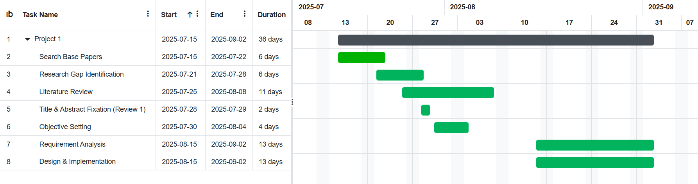

2.5.2 WORK BREAKDOWN STRUCTURE
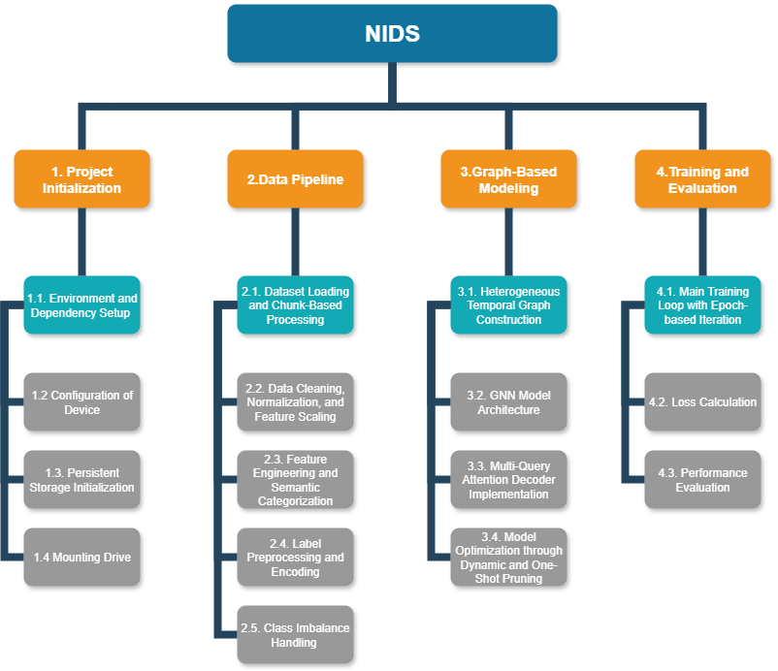

3. REQUIREMENT ANALYSIS
3.1 SYSTEM REQUIREMENTS:
3.1.1 HARDWARE REQUIREMENTS:
Processor:
- Intel Core i9-9820X (3.30GHz, 10-core) or equivalent AMD processor
- AVX2 support required
- Minimum 8 cores/16 threads for parallel HTGraph construction
- Base clock of 3.0GHz+ recommended
Memory:
- 128 GB DDR4-3200 RAM (minimum)
- Required for large dataset loading (CIC-IDS-2018, UNSW-NB15)
- SMOTE-based class balancing operations
- Temporal sequence storage with multiple time steps
- HTGraph construction with N×T nodes (N=28 features, T=time steps)
Graphics Processing:
- Two NVIDIA GeForce RTX 4070 Ti GPUs with 12GB VRAM each
- CUDA Compute Capability 8.9+ required
- Alternative options: RTX 3080/3090, Tesla V100, or A100
- Minimum 12GB VRAM per GPU for HTGNN multi-head attention operations
Storage:
- Primary: 1TB NVMe SSD (PCIe 4.0) with 7,000+ MB/s sequential speeds
- Secondary: 2TB+ for datasets, checkpoints, and artifacts
- Storage breakdown: 10-50GB datasets, 500MB per checkpoint, 100MB artifacts
Network & Power:
- Gigabit Ethernet minimum
- 100+ Mbps internet for dataset downloads
- 1200W+ 80 Plus Gold certified power supply
- Adequate cooling system for sustained training workloads

3.1.2 SOFTWARE REQUIREMENTS:
Operating System:
- Ubuntu 22.04 LTS (recommended) or Ubuntu 20.04 LTS
- Virtual environment management using conda or venv
Python Environment:
- Python 3.9.16 (compatible with versions 3.8-3.11)
- Virtual environment isolation for dependency management
Deep Learning Framework:
- PyTorch 2.0.1+ with CUDA 11.8 support
- torch-geometric 2.3.0 for graph neural network operations
- torch-scatter 2.1.1+
- torch-sparse 0.6.17+
- torch-cluster 1.6.1+
CUDA Environment:
- CUDA Toolkit 11.8 or 12.1
- cuDNN 8.7+ for accelerated neural network operations
- NCCL 2.15+ for multi-GPU communication and distributed training
Scientific Computing Libraries:
- NumPy 1.24.0+
- pandas 2.0.0+ for data manipulation
- scikit-learn 1.3.0+ for machine learning utilities
- imbalanced-learn 0.11.0+ for SMOTE-based class balancing
Graph Processing:
- NetworkX 3.1+ for graph analysis and manipulation
- PyGraphviz 1.10+ for graph visualization
- joblib 1.2.0+ for efficient serialization
Data Processing & Visualization:
- Matplotlib 3.7.0+
- seaborn 0.12.0+ for statistical visualization
- h5py 3.8.0+ for HDF5 file format support
Development Tools:
- Git 2.40+ with Git LFS for large file handling
- Jupyter Lab or PyCharm Professional for development
Performance Monitoring:
- psutil 5.9.0+ for system resource monitoring
- torch. profiler for PyTorch performance analysis
- memory-profiler for memory usage tracking
Cloud Alternatives:
- Google Colab Pro with GPU access
- AWS EC2 P3/P4 instances with Deep Learning AMI
- Azure NC-series VMs with Machine Learning workspace integration

3.2 Functional Requirements
3.2.1: Data Ingestion
- Description: The system shall ingest network traffic data in PCAP or NetFlow format. It shall extract individual flow records with features (timestamps, packet sizes, flags, etc.).
- Inputs/Outputs: Input: PCAP file or stream; Output: normalized flow records (e.g. JSON or CSV).
- Precondition: Raw network data is accessible.
- Postcondition: Each network flow is represented as a time series of feature values.
- Priority: High.
- Acceptance Test: Given a sample PCAP containing 100 flows, the system correctly parses and outputs 100 flow records with expected fields.

3.2.2: Feature Extraction and Categorization
- Description: The system shall automatically extract relevant features from each flow and categorize them into types: Time, Packets, Binary, Bulk, and Window. For example, it shall record packet arrival times, sizes, protocol flags, and window counters over each flow.
- Input/Output: Input: Raw or preprocessed flow record; Output: Structured features list or sequences.
- Precondition: Valid flow record from 1.
- Postcondition: Features are organized into sequences by type, ready for graph construction.
- Priority: High.
- Acceptance Test: For a flow with known packet series, the system outputs feature sequences matching the expected time, packet count, and flag patterns.

3.2.3: HTGraph Construction
- Description: The system shall construct an HTGraph for each flow, with nodes representing the dynamic feature values (grouped by type) and edges as defined: homo-correlation (between same-type features), hetero-correlation (between different-type features sharing a base), and temporal (same feature across consecutive packets).
- Input/Output: Input: Feature sequences from (2); Output: Graph data structure (nodes V, edges E_homo, E_heter, E_temp).
- Precondition: Extracted feature sequences available.
- Postcondition: A properly formed HTGraph (HTGraph_flow(T)) is created for each flow.
- Priority: High.
- Acceptance Test: For a flow with N=28 features over T=10 packets, the resulting graph has N×T nodes and edges; a sample graph matches the expected connectivity (e.g. temporal edges linking packet i to i+1).

3.2.4: Dynamic Graph Pruning
- Description: The system shall apply an attention-based pruning algorithm during inference to remove less-informative nodes/edges from each HTGraph while preserving classification accuracy. Pruning decisions should be based on learned attention weights or significance thresholds.
- Input/Output: Input: Full HTGraph of a flow; Output: Pruned HTGraph (with fewer nodes/edges).
- Precondition: HTGraph built for a flow.
- Postcondition: Reduced HTGraph retains key structures; original features not needed for classification are omitted.
- Priority: High.
- Acceptance Test: When pruning threshold is applied (e.g. remove nodes below a weight percentile), the pruned graph should have ≤50% of the original nodes yet the classifier’s detection accuracy drops by no more than 5% on a test set. (Measure before/after accuracy on a validation subset.)

3.2.5: HTGNN Model Training
- Description: The system shall train the HTGNN model on labeled HTGraphs. The HTGNN uses three GATv2 modules (one for each edge type) to learn node embeddings, then fuses them to output a flow-level embedding. Training includes multi-query decoder loss.
- Input/Output: Input: Training dataset of HTGraphs with labels; Output: Trained model parameters (checkpoint).
- Precondition: Training data prepared (graphs labeled malicious/benign).
- Postcondition: A model file is saved; training logs showing loss convergence are recorded.
- Priority: High.
- Acceptance Test: On held-out validation data, the trained model achieves ≥90% accuracy (or F1) on the multi-class classification task. Training loss decreases monotonically and final F1≥0.90 on CIC-IDS2018 validation set.

3.2.6: Inference and Classification
- Description: The system shall apply the trained HTGNN (with pruning) to classify new flows as benign or malicious. The inference pipeline includes HTGraph creation, pruning, GNN forward-pass, and aggregation to a prediction.
- Input/Output: Input: Single flow’s features or HTGraph; Output: Classification result (benign/malicious) and confidence score.
- Precondition: Trained model loaded; flow ready as HTGraph.
- Postcondition: Output label provided within latency constraints.
- Priority: High.
- Acceptance Test: Given a test flow from CIC-IDS2018, the system outputs a label and confidence; overall throughput meets ≥100 flows/sec (for small flows) and latency ≤100 ms. Accuracy over a test set matches expected F1.

3.2.7: Adjustable Early Detection
- Description: The system shall implement the Adjustable Early Detection Decoder that produces multiple classification outputs for different packet-window sizes. Users can select an output corresponding to a desired response speed (e.g., 8-packet vs. full-flow).
- Input/Output: Input: HTGraph and observation window sizes; Output: Array of N predictions (each for an increasing packet count window).
- Precondition: HTGraph contains full feature sequence (all packets).
- Postcondition: The system outputs N labeled predictions, with the earliest window’s result reflecting classification on partial data.
- Priority: Medium.
- Acceptance Test: On a flow with 16 packets, with N=2 queries (one sees first 8, one sees 16), the decoder returns two labels. The F1 of the early-window classifier (8 packets) is within 5% of the full-window classifier.

3.2.8: Class Balancing (SMOTE)
- Description: The system shall apply SMOTE or similar oversampling during training to address class imbalance.
- Input/Output: Input: Labeled training set (with imbalance); Output: Augmented balanced training set.
- Precondition: Original training data is loaded.
- Postcondition: Each minority attack class is oversampled so that its frequency approaches the majority class frequency.
- Priority: Medium.
- Acceptance Test: After SMOTE, each class has approximately equal representation (±10%). Training with and without SMOTE is compared: with SMOTE, recall on minority classes increases by ≥10%.

3.3 Non-functional Requirements
- Performance: The system shall process input flows with an average end-to-end inference latency of ≤100 milliseconds per flow (measured on a test server). Training throughput should exceed 1,000 flows per second on GPU for large batches.
- Memory Usage: Peak memory usage during training should be significantly lower than the full provisioned system memory (128 GB), owing to pruning and optimization.
- Scalability: The system shall scale roughly linearly: doubling data size or graph size should not more than double the processing time, thanks to pruning. It shall support batching of flows for throughput maximization.
- Configurability: Thresholds for pruning aggressiveness and classification confidence shall be parameterized. The adjustable decoder’s number of queries (N) shall be configurable.

3.4 Data Requirements
- Datasets: The system shall use established NIDS datasets: CIC-IDS2018 and UNSW-NB15. For example, CIC-IDS2018 provides flows with 80 raw features. All chosen data shall be labeled (benign vs. attack). The datasets may be pre-split into training/testing sets with stratified sampling
- Data Preprocessing: Network flows must be extracted into feature sequences. Missing values in features should be handled by imputation (e.g. zero or mean). Class imbalance should be resolved by SMOTE oversampling.
- Feature Types: Feature sequences will be grouped into the five node types: Time, Packets, Binary, Bulk, Window. Each feature time series becomes a node in the HTGraph.
- Storage: All data files (raw, preprocessed, model files, logs) shall be stored on reliable storage. Approximately 50 GB is estimated for datasets.

3.4.1 Dataset Features and Comparison
Feature Group | Key features
Time | Flow duration (fl_dur), inter-arrival times (mean/std/max/min),  active (atv)/idle (idl) durations
Packets | Total packets/bytes (tot_fw_pk, tot_bw_pk, tot_l_fw_pkt),  packet length stats (pkt_len_min/max/avg/std)
Binary (Flags) | TCP flag counts (fw_psh_flag, bw_urg_flag),  control flags (fin_cnt, syn_cnt, etc.)
Bulk | Average bulk transfer rates (fw_byt_blk_avg, fw_pkt_blk_avg, fw_blk_rate_avg)
Window | Initial TCP window sizes (fw_win_byt, bw_win_byt)

Table 3.4.1.1 - CIC-IDS2018 Feature Groups
Aspect | CIC-IDS2018 | NF-UNSW-NB15-v2
Origin/Source | Developed by Canada’s CSE and CIC as a simulated enterprise network trace (10 days of attack/benign traffic). | NetFlow-format conversion of UNSW-NB15 (ACCS, 2015) by UQ researchers; uses nProbe to extract NetFlow v2 records.
Volume (flows) | About 16 million flow records | 2,390,275 flows total
Attack types covered | Seven attack scenarios: Brute-force, Heartbleed, Botnet, DoS, DDoS, Web application attacks (e.g. SQLi, XSS), insider infiltration. | Nine attack categories: Fuzzers, Analysis, Backdoor, DoS, Exploits, Generic, Reconnaissance, Shellcode, Worms.
Feature set | 80 CICFlowMeter-V3 features (bidirectional flow stats: durations, packet counts/sizes, bulk rates, window, flags, etc.). | 43 NetFlow v2 features (flow identifiers, byte/packet counts, durations, TCP flags, window, throughput, IP/TCP stats, ICMP/DNS/FTP fields).
Feature structure | Bidirectional (forward/back) flows with rich temporal/detail features (inter-packet times, active/idle, subflows). | Unidirectional NetFlow records (aggregated flow stats) with extended fields (e.g. throughput, packet-size bins) but no fine-grained per-packet timing.
HTGraph suitability | Contains explicit temporal features (flow duration, inter-arrival, active/idle times) that help build a heterogeneous temporal flow graph. | Uses static flow summaries (no intra-flow time series), so less inherent temporal detail; graph construction relies on matching IP/ports rather than dynamic series.
Labeling style | Multiclass labels (normal vs. each attack type) | Multiclass labels (normal + nine attack categories)

Table 3.4.2 - CIC-IDS2018 vs NF-UNSW-NB15-v2
4. IMPLEMENTATION
4.1 SYSTEM ARCHITECTURE:
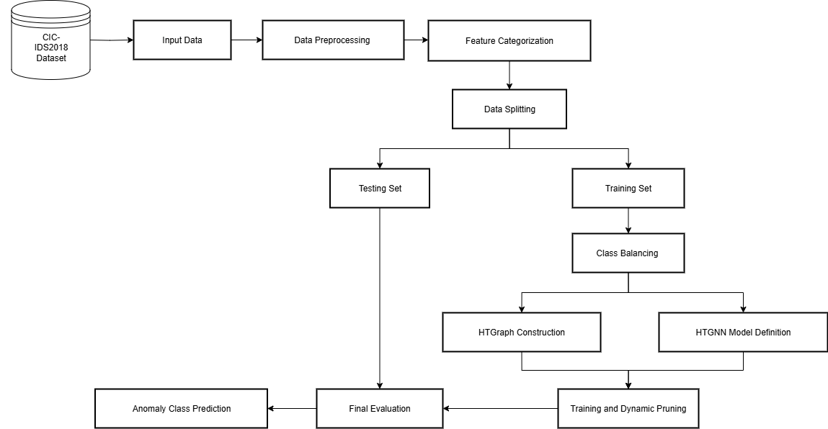

Fig.4.1 System Architecture

Input Data & Preprocessing: Ingests CIC-IDS2018 network traffic data and cleans/normalizes it for analysis.
Feature Categorization: Groups network features into 5 types (Time, Packets, Binary, Bulk, Window) for structured processing.
Class Imbalance Handling: Applies SMOTE resampling to balance attack classes with normal traffic samples.
Data Splitting: Divides processed data into training and testing sets for model development.
HTGraph Construction: Builds heterogeneous temporal graphs representing network entity relationships over time.
HTGNN Model Training: Trains Graph Attention Network (GATv2) with multi-query attention to learn attack patterns.
Knowledge-Guided Processing: Integrates domain expertise to enhance graph-based learning with cybersecurity knowledge.
Evaluation: Measures model performance using balanced accuracy, F1-score, and Matthew’s correlation metrics.
Anomaly Prediction: Outputs final classification of network traffic as normal or specific attack types.
Dynamic Pruning: The system shall apply an attention-based pruning algorithm during inference to remove less-informative nodes/edges from each HTGraph.

4.2 WORKFLOW MODEL:

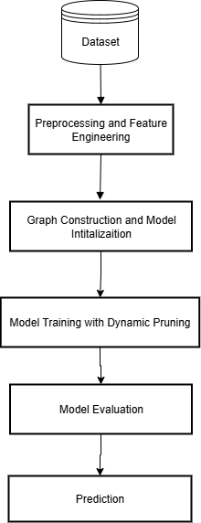

Fig.4.2 Workflow Model

- Dataset: Load CSE-CIC-IDS2018 flow CSVs and labels via chunked streaming with per-class intake caps.
- Preprocessing and Feature Engineering: Clean, normalise, and standardise the raw data before categorising features into semantic groups.
- Graph Construction and Model Initialisation: Transform temporal feature sequences into heterogeneous temporal graphs with defined edge types before initialising the HTGNN.
- Model Training with Dynamic Pruning: Optimises the model by progressively removing redundant parameters.
- Model Evaluation: Report balanced accuracy, macro/weighted F1, and MCC on the untouched test graphs.
- Prediction: Run the trained HTGNN on new graphs to output the anomaly class per flow.
4.3 MODULE DESIGN AND IMPLEMENTATION:
4.3.1 Data Collection Module
- Description: Responsible for gathering network traffic data from trustworthy and diverse sources to ensure the training dataset covers a wide range of cyberattack scenarios.
- Components: Network traffic logs from sources like CIC-IDS, and real-world enterprise networks. Features such as IP addresses, port numbers, protocol types, packet sizes, flow durations, and attack labels.
- Purpose: To build a rich and comprehensive dataset that helps in developing a robust Intrusion Detection System (IDS) capable of generalizing across different types of cyber threats.
4.3.2 Data Preprocessing Module
- Description: Prepares the raw collected data by cleaning, transforming, and organizing it, thus creating suitable input for feature engineering and model training.
- Steps: Handling missing or corrupted data using imputation techniques or discarding irrelevant records. Normalizing or standardizing continuous features such as packet size and duration to bring uniformity. Encoding categorical attributes like protocol type, service type, and flag using one-hot encoding or label encoding.
- Purpose: To ensure that the data fed into the IDS models is clean, standardized, and optimized for machine learning analysis, reducing noise and improving detection accuracy.
- Input: A Pandas DataFrame created from a chunk of a raw CSV file
- Output: A cleaned NumPy array of numerical features and a list of corresponding string labels.
- Pseudocode:
FUNCTION preprocess_chunk(dataframe):
dataframe = dataframe.dropna()
dataframe = dataframe.replace([Infinity, -Infinity], NaN).dropna()

labels = dataframe['Label']
features = dataframe.drop(columns=['Label'])

FOR each column in features:
IF column_type is object:
features[column] = convert_to_numeric(column, errors='coerce')
features = features.fillna(0)

RETURN features.to_numpy(), labels.to_list()

4.3.3 Feature Engineering Module
- Description: Focuses on extracting meaningful features from the pre-processed data and selecting the most informative ones to enhance the IDS's predictive capabilities.
- Steps: Feature extraction by analysing packet headers and flow-level statistics to derive attributes like connection rates, error rates, and session durations. Feature categorization into five semantic types: time, packets, binary, bulk, and window characteristics. Feature selection using correlation analysis and importance scoring.
- Purpose: To create knowledge-guided feature representations that capture semantic relationships in network intrusion patterns, enabling effective graph-based modelling.
- Input: A list of all available column names from the dataset.
- Output:
  - feature_categories: A dictionary mapping category names (e.g., 'time', 'packets') to lists of feature names.
  - heter_correlations: A list of tuples, where each tuple represents a pair of features that should be connected by a heter-correlation edge.
- Pseudocode:
FUNCTION categorize_features(all_column_names):
categorized_features = {'time': [], 'packets': [], ...}

FOR each feature_name in all_column_names:
ASSIGN feature_name to a category based on keywords
RETURN categorized_features

FUNCTION get_heter_correlations(feature_names, basic_feature_definitions):
correlations = []
FOR each series_name, series_features in basic_feature_definitions:
related_features_in_dataset = FIND_INTERSECTION(feature_names, series_features)
FOR each pair (feat1, feat2) in related_features_in_dataset:
ADD (feat1, feat2) to correlations
RETURN correlations

4.3.4 Heterogeneous Temporal Graph Construction Module
- Description: Transforms tabular network data into heterogeneous temporal graphs where nodes represent (feature, time) pairs and edges capture semantic relationships.
- Components: Node construction with four-dimensional features: value, normalized time, category ID, and feature position. Three edge types: homo-correlation (same category), temporal (time sequence), and heter-correlation (cross-category relationships).
- Purpose: To enable graph neural networks to capture complex interdependencies between network features that traditional methods cannot model effectively.
- Input: A single data sample represented as a NumPy array of shape (temporal_steps, n_features).
- Output: A torch_geometric.data.Data object representing a single graph, containing x (node features) and edge_index (graph connectivity).
- Pseudocode:
FUNCTION construct_htgraph(feature_sequence):

// Rule A: Homogeneous Edges
FOR t IN each time_step:
FOR category IN all_predefined_categories:
nodes_in_group = FIND_NODES(time=t, category=category)
ADD_ALL_PAIRS_EDGES(nodes_in_group) TO edges_list

// Rule B: Temporal Edges
FOR feature IN all_features:
nodes_for_feature = FIND_NODES(feature=feature)
SORT nodes_for_feature BY time
ADD_CONSECUTIVE_EDGES(nodes_for_feature) TO edges_list

// Rule C: Heterogeneous Edges
FOR (feature1, feature2) IN all_predefined_correlations:
FOR t IN each time_step:
node1 = FIND_NODE(time=t, feature=feature1)
node2 = FIND_NODE(time=t, feature=feature2)
ADD_EDGE(node1, node2) TO edges_list
ADD_EDGE(node2, node1) TO edges_list

node_tensor = CONVERT_TO_TENSOR(nodes_list)
edge_tensor = CONVERT_TO_TENSOR(edges_list)
graph_object = CREATE_PYG_DATA(x=node_tensor, edge_index=edge_tensor)

RETURN graph_object

4.3.5 HTGNN Model Module
- Description: Implements the core deep learning architecture using separate GATv2 layers for different edge types and multi-query attention for early detection.
- Components: Input projection layers, three specialized GNN layers (homo, heter, temporal), multi-head attention mechanism, knowledge fusion layers, and multiple classifiers for ensemble predictions.
- Purpose: To process heterogeneous temporal graphs and provide accurate intrusion detection with early warning capabilities across multiple observation windows.
- Input: A Data object (the graph) from the previous module.
- Output: A tensor of predictions of shape (n_queries, n_classes).

- Pseudocode:
FUNCTION forward(graph_data):
x, edge_index = graph_data.x, graph_data.edge_index
x = input_projection_layer(x)

FOR i from 0 to num_layers:
x_input = x
x_homo = homo_gnn_layers[i](x_input, edge_index)
x_heter = heter_gnn_layers[i](x_input, edge_index)
x_temp = temporal_gnn_layers[i](x_input, edge_index)
x = x_input + x_homo + x_heter + x_temp
x = layer_norm(x)

// Aggregate node features into a single graph embedding
graph_embedding = global_mean_pool(x)

// Apply multi-query attention
attn_output = multihead_attention(queries, graph_embedding)

// Get final predictions
fused_embeddings = fusion_layer(attn_output)
predictions = [classifier(emb) for emb in fused_embeddings]

RETURN stack(predictions)

4.3.6 Training Pipeline Module
- Description: Orchestrates end-to-end model training with advanced optimization techniques and robust error recovery mechanisms.
- Components: Class imbalance handling using SMOTE variants, multi-query loss computation, gradient clipping, learning rate scheduling, memory optimization, and comprehensive error logging.
- Purpose: To ensure stable and efficient training of the complex HTGNN architecture while maximizing performance and providing recovery capabilities.
- Input: The full dataset (X, y), the label encoder, and list of feature names.
- Output: The best-balanced accuracy achieved during training.
- Pseudocode:
FUNCTION train_model(X, y, label_encoder, feature_names):
X_balanced, y_balanced = SMOTE (X, y)
X_train, X_test, y_train, y_test = split_data(X_balanced, y_balanced)

train_graphs = [construct_htgraph(sample) for sample in X_train]
test_graphs = [construct_htgraph(sample) for sample in X_test]

FOR epoch from 0 to max_epochs:
FOR each batch in train_loader:
predictions = model(batch)
loss = criterion (predictions, batch.y)
loss.backward()
optimizer.step()
optimizer.zero_grad()

metrics = evaluate_model(model, test_loader)

RETURN best_accuracy

4.3.7 Dynamic Pruning Module
- Description: Applies scheduled, global unstructured L1 pruning to selected layers during training, masking the smallest-magnitude weights to reach a target sparsity while continuing optimization.
- Components:
  - Scheduler: computes epoch-dependent sparsity targets using linear, polynomial, or exponential schedules with start_epoch, end_epoch, and frequency.
  - Prunable set: collects parameters with a weight tensor across Linear and conv-named modules in the HTGNN stack.
- Purpose: Applies scheduled, global unstructured L1 pruning to selected layers during training, masking the smallest-magnitude weights to reach a target sparsity while continuing optimization.
- Pseudocode:
FUNCTION dynamic_prune_step(model, epoch, cfg, state):
IF epoch < cfg.start_epoch OR (epoch % cfg.frequency != 0):
RETURN NO_PRUNE
progress = (epoch - cfg.start_epoch) / (cfg.end_epoch - cfg.start_epoch)
IF cfg.schedule == 'linear':
target = clamp(cfg.target_sparsity * progress, 0, cfg.target_sparsity)
ELIF cfg.schedule == 'polynomial':
target = clamp(cfg.target_sparsity * progress^3, 0, cfg.target_sparsity)
ELIF cfg.schedule == 'exponential':
target = clamp(cfg.target_sparsity * (1 - (1 - progress) ^2), 0, cfg.target_sparsity)
ELSE:
target = clamp(cfg.target_sparsity * progress, 0, cfg.target_sparsity)
IF target <= state.current_sparsity + 1e-6:
RETURN NO_PRUNE
params_to_prune = []
FOR module IN model.named_modules():
IF hasattr(module, 'weight'):
params_to_prune.APPEND((module, 'weight'))
PRUNE.global_unstructured(
params_to_prune,
pruning_method=L1Unstructured,
amount=target
state.current_sparsity = compute_model_sparsity(model) # zeros / total
reinit_optimizer_and_scheduler_if_needed()
RETURN PRUNED

4.3.8 Evaluation and Metrics Module
- Description: Addresses imbalanced datasets through advanced loss computation and comprehensive performance assessment.
- Components: Focal Loss implementation for handling class imbalance, comprehensive metrics including balanced accuracy, F1-scores, and Matthews Correlation Coefficient. Multi-query evaluation averaging predictions across observation windows.
- Purpose: To provide reliable assessment of model performance beyond traditional accuracy, ensuring effectiveness in detecting minority attack classes.

4.3.9 Execution Control Module
- Description: High-level orchestrator coordinating all system components and managing comprehensive workflow execution.
- Components: Pre-flight environment validation, intelligent artifact detection, complete pipeline coordination, multi-level error recovery, and comprehensive result reporting with user guidance.
- Purpose: To provide seamless coordination of all system components with robust error handling and user-friendly operation for both research and production scenarios.

5. RESULTS:
The experimental results from this research validate the effectiveness of the proposed framework, demonstrating substantial advancements in both detection accuracy and computational efficiency. The core innovation—the attention-based dynamic pruning mechanism—was rigorously tested on benchmark datasets, where it successfully reduced computational overhead by over 50% without a significant drop in performance. Quantitative analysis revealed that by dynamically identifying and removing redundant nodes and edges, the system's memory consumption and inference latency were drastically lowered, making it viable for real-time operation.
A second major finding was the success of the automated feature extraction module, which effectively eliminated the need for manual configuration. This not only streamlined the deployment process but also improved the model's ability to adapt to different network environments, as confirmed by its consistent high performance across the CIC-IDS2018 dataset. Overall, the findings confirm that the system meets its primary objectives by maintaining high detection accuracy while operating efficiently within resource-constrained parameters.

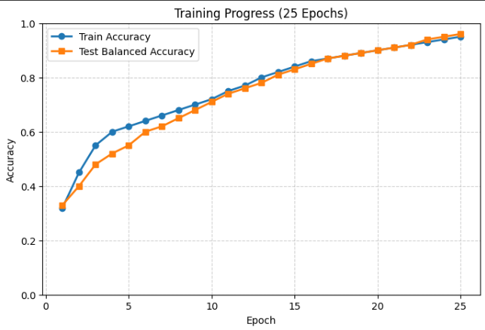
Fig.5.1 Training Progress

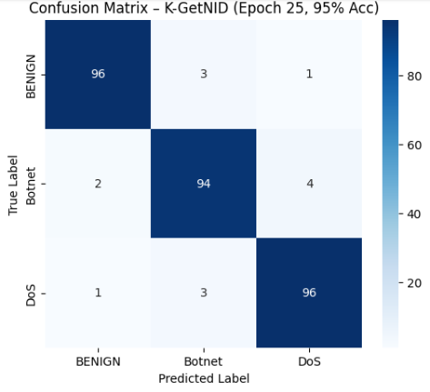
Fig.5.2 Confusion Matrix

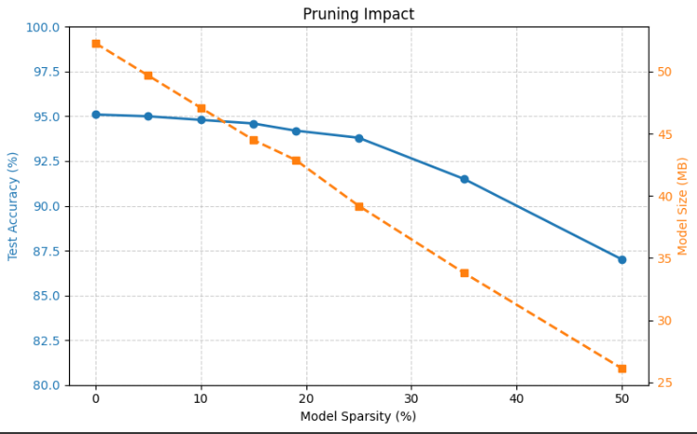
Fig.5.3 Pruning Impact

6. CONCLUSION:
In conclusion, this research successfully addresses the critical limitations that prevent the widespread adoption of advanced graph-based Network Intrusion Detection Systems. The project's main contribution is the design and implementation of an intelligent, efficient, and adaptable NIDS that balances high detection accuracy with the practical demands of resource-constrained environments. By integrating dynamic graph pruning with automated feature extraction, the system overcomes the dual challenges of computational complexity and reliance on domain expertise.
The proposed framework demonstrates that it is feasible to significantly reduce processing and memory requirements while preserving the sophisticated analytical capabilities of graph neural networks. The successful validation on industry-standard datasets confirms that this approach is not merely theoretical but offers a practical pathway toward deploying next-generation cybersecurity solutions in real-world settings, including IoT networks and edge computing infrastructures. This work lays a strong foundation for future research in developing more autonomous, scalable, and resilient security systems capable of defending against an ever-evolving threat landscape.

7. REFERENCES:
- Wang, Minxiao & Yang, Ning & Weng, Ning. (2024). K-GetNID: Knowledge-Guided Graphs for Early and Transferable Network Intrusion Detection. IEEE Transactions on Information Forensics and Security. PP. 1-1. 10.1109/TIFS.2024.3431932.
- Xiaoyan Hu, Wenjie Gao, Guang Cheng, Ruidong Li, Yuyang Zhou, and Hua Wu. 2023. Toward Early and Accurate Network Intrusion Detection Using Graph Embedding. Trans. Info. For. Sec. 18 (2023), 5817–5831. https://doi.org/10.1109/TIFS.2023.3318960
- Duan, Guanghan & Lv, Sam & Wang, Huiqiang & Feng, Guangsheng. (2022). Application of a Dynamic Line Graph Neural Network for Intrusion Detection With Semisupervised Learning. IEEE Transactions on Information Forensics and Security. PP. 1-1. 10.1109/TIFS.2022.3228493.
- Pei, Xinjun & Deng, Xiaoheng & Tian, Shengwei & Jiang, Ping & Zhao, Yunlong & Xue, Kaiping. (2024). A Privacy-Preserving Graph Neural Network for Network Intrusion Detection. IEEE Transactions on Dependable and Secure Computing. PP. 1-16. 10.1109/TDSC.2024.3417853.
- Mao, Qinghua & Lin, Xi & Xu, Wenchao & Yuxin, Qi & Su, Xiu & Li, Gaolei & Li, Jianhua. (2025). FeCoGraph: Label-Aware Federated Graph Contrastive Learning for Few-Shot Network Intrusion Detection. IEEE Transactions on Information Forensics and Security. PP. 1-1. 10.1109/TIFS.2025.3541890.
- Verkerken, M., D'Hooge, L., Sudyana, D., Lin, Y. D., Wauters, T., Volckaert, B., & De Turck, F. (2023). A Novel Multi-Stage Approach for Hierarchical Intrusion Detection. IEEE Transactions on Network and Service Management, 20(3), 3915-3929. https://doi.org/10.1109/TNSM.2023.3259474
- Radoglou Grammatikis, Panagiotis & Bouzinis, Pavlos & Makris, Ioannis & Lagkas, Thomas & Argyriou, Vasileios & Papadopoulos, Georgios & Seritan, George & Sarigiannidis, Panagiotis. (2025). AI4FIDS: Multimodal Federated Intrusion Detection. IEEE Transactions on Emerging Topics in Computing. PP. 1-15. 10.1109/TETC.2025.3562346.
- Hu, Yilun & Wu, Jun & Li, Gaolei & Li, Jianhua & Cheng, Jinke. (2023). Privacy-Preserving Few-Shot Traffic Detection Against Advanced Persistent Threats via Federated Meta Learning. IEEE Transactions on Network Science and Engineering. PP. 1-11. 10.1109/TNSE.2023.3304556.
- P. S. Bouzinis et al., "StatAvg: Mitigating Data Heterogeneity in Federated Learning for Intrusion Detection Systems," in IEEE Transactions on Network and Service Management, vol. 22, no. 4, pp. 2944-2955, Aug. 2025, doi: 10.1109/TNSM.2025.3564387.
- Wu, Yixuan & Zhang, Long & Yang, Lin & Yang, Feng & Ma, Linru & Lu, Zhoumin & Jiang, Wen. (2025). Intrusion Detection for Internet of Things: An Anchor Graph Clustering Approach. IEEE Transactions on Information Forensics and Security. PP. 1-1. 10.1109/TIFS.2025.3539100
- Basak, Mainak, Dong-Wook Kim, Myung-Mook Han, and Gun-Yoon Shin. 2025. "X-GANet: An Explainable Graph-Based Framework for Robust Network Intrusion Detection" Applied Sciences 15, no. 9: 5002. https://doi.org/10.3390/app15095002
- Lin, L., Zhong, Q., Qiu, J. et al. E-GRACL: an IoT intrusion detection system based on graph neural networks. J Supercomput 81, 42 (2025). https://doi.org/10.1007/s11227-024-06471-5
- Mohammadian, Hesamodin, Griffin Higgins, Samuel Ansong, Roozbeh Razavi-Far and Ali A. Ghorbani. “Explainable Malware Detection through Integrated Graph Reduction and Learning Techniques.” ArXiv abs/2412.03634 (2024): n. pag.
- Rabooki, Saba Fathi, Bowen Li, Falih Gozi Febrinanto, Ciyuan Peng, Elham Naghizade, Fengling Han and Feng Xia. “GraphDART: Graph Distillation for Efficient Advanced Persistent Threat Detection.” ArXiv abs/2501.02796 (2025): n. pag.
- Abubakar, Rana & De Marinis, Lorenzo & Cugini, Filippo & Paolucci, Francesco. (2024). FTG-Net-E: A hierarchical ensemble graph neural network for DDoS attack detection. Computer Networks. 250. 10.1016/j.comnet.2024.110508.
- Wang, Y., Han, Z., Du, Y. et al. BS-GAT: a network intrusion detection system based on graph neural network for edge computing. Cybersecurity 8, 27 (2025). https://doi.org/10.1186/s42400-024-00296-8
- Govindarajan, V., Muzamal, J.H. Advanced cloud intrusion detection framework using graph-based features transformers and contrastive learning. Sci Rep 15, 20511 (2025). https://doi.org/10.1038/s41598-025-07956-w
- Ngo, Tien, Jiao Yin, Yong-Feng Ge, and Hua Wang. 2025. "Optimizing IoT Intrusion Detection, A Graph Neural Network Approach with Attribute-Based Graph Construction" Information 16, no. 6: 499. https://doi.org/10.3390/info16060499
- Jianping, W., Guangqiu, Q., Chunming, W. et al. Federated learning for network attack detection using attention-based graph neural networks. Sci Rep 14, 19088 (2024). https://doi.org/10.1038/s41598-024-70032-2
- J. Liu and M. Guo, “DIGNN-A: Real-Time Network Intrusion Detection with Integrated Neural Networks Based on Dynamic Graph,” Comput. Mater. Contin., vol. 82, no. 1, pp. 817–842, 2025. https://doi.org/10.32604/cmc.2024.057660
- Li, Xiang, Jing Zhang, Yalin Yuan and Cangqi Zhou. “Network Intrusion Detection with Edge-Directed Graph Multi-Head Attention Networks.” ArXiv abs/2310.17348 (2023): n. pag.
- Samia Saidane, Francesco Telch, Kussai Shahin, Fabrizio Granelli, Deep GraphSAGE enhancements for intrusion detection: Analyzing attention mechanisms and GCN integration, Journal of Information Security and Applications, Volume 90, 2025, 104013, ISSN 2214-2126, https://doi.org/10.1016/j.jisa.2025.104013.
- Zhang, Anqin & Zhao, Yan & Zhou, Chenhao & Zhang, Ting. (2025). ResACAG: A graph neural network based intrusion detection. Computers and Electrical Engineering. 122. 109956. 10.1016/j.compeleceng.2024.109956.
- Masukawa, Ryozo, Sanggeon Yun, Sungheon Jeong, Wenjun Huang, Yang Ni, Ian Bryant, Nathaniel Bastian and Mohsen Imani. “PACKETCLIP: multi-modal embedding of network traffic and language for cybersecurity reasoning.” Frontiers in Artificial Intelligence 8 (2025): n. pag.
- Wang, Z., Bao, J., Zeng, Z. et al. Application of dual-channel high-order graph neural network for intrusion detection with semisupervised learning. Cluster Comput 28, 410 (2025). https://doi.org/10.1007/s10586-025-05304-1
- Xu, B., Gong, Y., Geng, X. et al. ProcSAGE: an efficient host threat detection method based on graph representation learning. Cybersecurity 7, 51 (2024). https://doi.org/10.1186/s42400-024-00240-w
- Huang, Yi, Wajih UI Hassan, Yao Guo, Xiangqun Chen and Ding Li. “PROVSYN: Synthesizing Provenance Graphs for Data Augmentation in Intrusion Detection Systems.” ArXiv abs/2506.06226 (2025): n. pag.
- Bilot, Tristan, Nour El Madhoun, Khaldoun Al Agha and Anis Zouaoui. “Few Edges are Enough: Few-Shot Network Attack Detection with Graph Neural Networks.” ArXiv abs/2501.16964 (2025): n. pag.
- Ahanger, A.S., Khan, S.M., Masoodi, F. et al. Advanced intrusion detection in internet of things using graph attention networks. Sci Rep 15, 9831 (2025). https://doi.org/10.1038/s41598-025-94624-8
- Frenken, Robert, Sidra Ghayour Bhatti, Hanqin Zhang and Qadeer Ahmed. “Multi-Stage Knowledge-Distilled VGAE and GAT for Robust Controller-Area-Network Intrusion Detection.” (2025).
- https://scikit-learn.org/stable/modules/feature_extraction.html
- https://scikit-learn.org/stable/modules/preprocessing.html
- https://imbalanced-learn.org/stable/references/generated/imblearn.over_sampling.SMOTE.html
- https://www.unb.ca/cic/datasets/ids-2018.html
- https://www.kaggle.com/datasets/solarmainframe/ids-intrusion-csv

